TITLE : DEVOPS(ASSIGNMENT -1)

1. Creating and Renaming Files/Directories
Create a directory named test_dir using mkdir.
Inside test_dir, create an empty file called example.txt.
Rename example.txt to renamed_example.txt using mv

Creating and Renaming Files/Directories
- mkdir is used to create a new directory.
- touch creates an empty file.
- mv is used to rename or move files.

2. Viewing File Contents
Use cat to display the contents of /etc/passwd.
Display only the first 5 lines of /etc/passwd using head.
Display only the last 5 lines of /etc/passwd using tail.

Viewing File Contents
- cat displays the entire content of a file.
- head shows the first few lines of a file.
- tail shows the last few lines of a file.

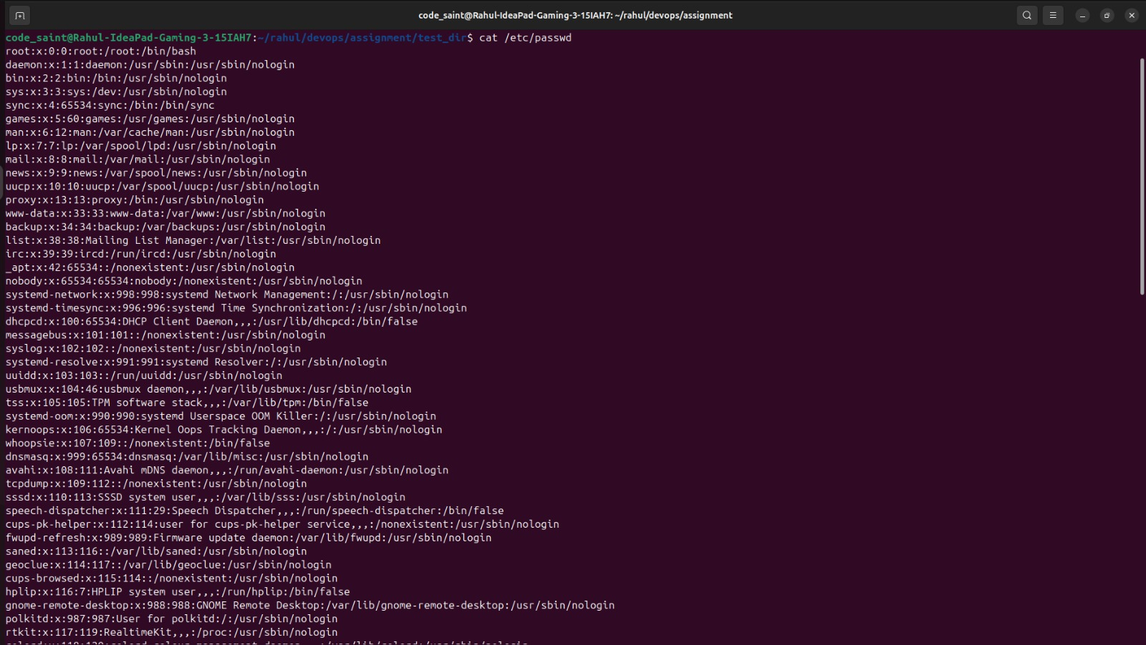

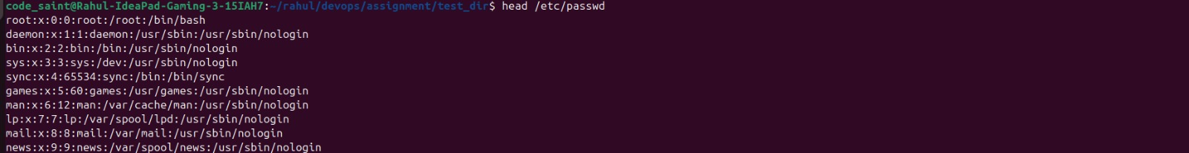

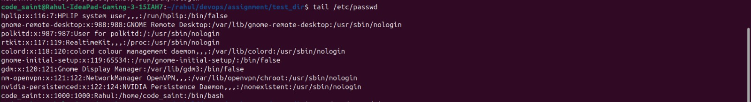

3.Searching for Patterns
Use grep to find all lines containing the word "root" in /etc/passwd.

Searching for Patterns
- grep searches for a specific word or pattern inside a file.

4. Zipping and Unzipping
Compress the test_dir directory into a file named test_dir.zip using zip.
Unzip test_dir.zip into a new directory named unzipped_dir.

Zipping and Unzipping
- zip compresses files or directories into a zip archive.
- unzip extracts files from a zip archive.

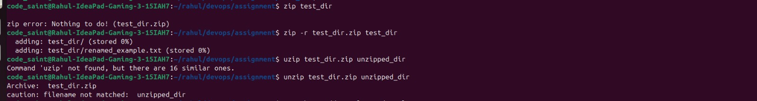

5. Downloading Files
Use wget to download a file from a URL (e.g., https://example.com/sample.txt).

Downloading Files
- wget downloads files from the internet using a URL.

6. Changing Permissions
Create a file named secure.txt and change its permissions to read-only for everyone using chmod.

Changing Permissions
- chmod is used to change file permissions.
- Permission 444 makes a file read-only for everyone.

7. Working with Environment Variables
Use export to set a new environment variable called MY_VAR with the value "Hello, Linux!".
Working with Environment Variables
- export creates or sets an environment variable.
- Environment variables store values used by the system or programs.

